Momin
Geospatial Consultant

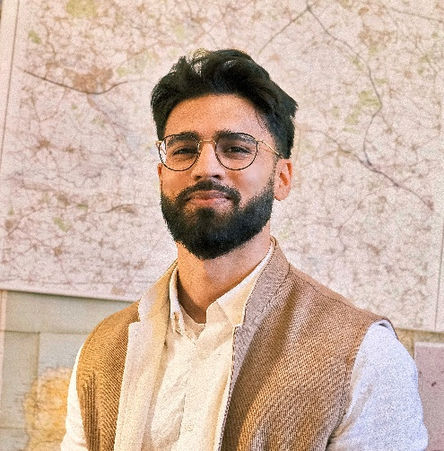
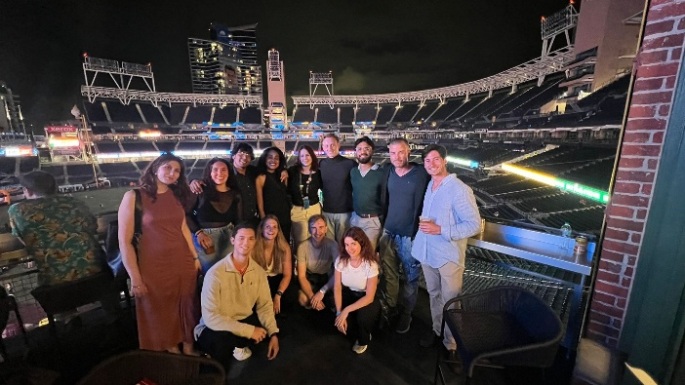

Credit: Momin Ashraf

Name: Momin
Job title: Geospatial Consultant
Organisation: Satellite Applications Catapult
Education: Degree in Geography (BA), University of Leicester. Masters in Sustainable Urban Development, University of Oxford
What is your job role and what do you do?
The Satellite Applications Catapult is a technology company that operates within the space industry. It is an interesting organisation because its role is to bring together academia, government, and industry to develop innovative solutions and help grow the UK’s space economy.
Credit: Momin Ashraf
My role involves supporting organisations to use satellite and mapping data, also known as geospatial data, so they can make better use of it in their work and achieve their goals more effectively. This means I work on projects across a wide range of sectors, including urban development, extractive industries, agriculture, transportation, and more.
A large part of my job involves supporting the Foreign, Commonwealth & Development Office (FCDO) with international development and humanitarian projects. In this role, I use satellite technology to support disaster response and conflict monitoring. As the lead analyst for the FCDO programmes I work on, I support projects across the Middle East, North Africa, and Central Africa. I use cutting-edge machine learning techniques to contribute to research projects and provide insights that help inform policy and decision-making.

How did you get to where you are now?
A Geography degree was essential for my career because it gave me an early introduction to Geographic Information Science (GIS) and remote sensing, which is the analysis of satellite imagery. These subjects are rarely offered as part of other degree programmes.

What also helped was how broad and varied Geography is. I went from learning about GIS and remote sensing to studying geopolitics, philosophy, weather systems, and soil science. This wide-ranging understanding of both human and physical geography has given me a better understanding of the challenges we face and allows geographers to take a more holistic and critical view of problems compared with many other disciplines.

The biggest benefit for my career was the year in industry that I completed during university. A year in industry is an additional year of paid work experience that takes place after your second year before returning for your final year. Many universities offer students the opportunity to work at a company of their choice, and many organisations advertise roles specifically for year-in-industry students. It is a great way to apply what you have learned at university in a professional environment, explore potential career paths, and develop skills that will help you after graduation.

For me, this provided the opportunity to work as a Research Assistant at the University of Leicester's Centre for Landscape and Climate Research. The aim of the project was to predict forest biomass, which is the dry mass of trees and can be used as a measure of forest density, using satellite imagery. The project already had biomass data collected on the ground by a postdoctoral researcher who measured trees in the Yucatán Peninsula in southern Mexico by recording their height and trunk width.

My role was to combine this ground-truth data with satellite imagery and machine learning techniques to create predictive models that could estimate biomass across the rest of Mexico and beyond. This was my first experience of applying the knowledge I had gained at university in a professional setting, with meetings, project deadlines, and collaborative problem-solving. It confirmed my interest in remote sensing and gave me the confidence to pursue it further, so I invested more time in developing my skills in this area.

What skills and characteristics do you need for this role, apart from geographical knowledge?
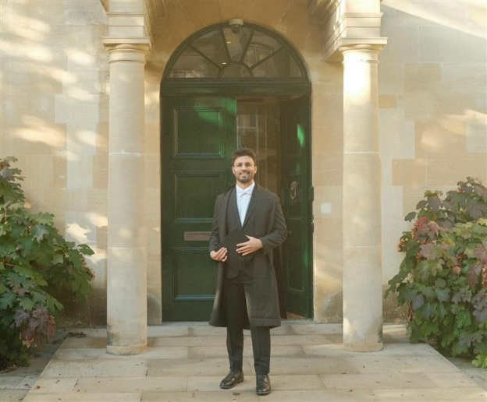

One skill that I largely taught myself, particularly through work experience, was Python programming. Before that, I had never been a fan of coding but learning it in a context that I was genuinely interested in made it much easier. Very quickly, it became something that I really enjoyed. There are countless free resources available online for learning Python, ranging from YouTube tutorials to dedicated open-source learning platforms.
Credit: Momin Ashraf

Data visualisation and design skills were another area that I developed through an additional university module. Understanding how to make your work aesthetically pleasing, while applying fundamental design principles, is an incredibly transferable skill that I would highly recommend developing. There are core principles of design, composition, and colour theory that apply across almost all creative and professional fields. While these “rules” can certainly be broken, understanding what works, what does not, and how to create visually impactful maps, posters, and presentation decks has been an invaluable skill throughout my career.

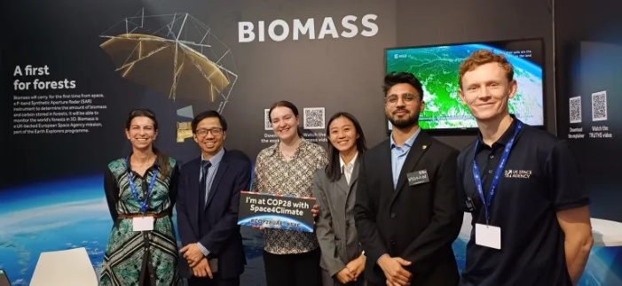
Presentation and interpersonal skills are by far the most important. These are difficult to learn from a textbook and are best developed through experience. As a shy child growing up, I could have written a guide on how to avoid public speaking, large gatherings, and social situations altogether. However, being repeatedly pushed outside my comfort zone has been essential, not only for my career but also for my personal development. I would encourage anyone to join sports clubs, societies, or extracurricular activities, and to seek opportunities for professional interaction wherever possible. This could be through working in a coffee shop, helping at university marketing stands, volunteering, or taking on customer-facing internships. These interpersonal skills will pay dividends when you enter the workplace and will often be just as valuable as your technical expertise.
Credit: Momin Ashraf

What do you enjoy most about your job? What have been your favourite projects?
My favourite project is hard to choose, but one that has always stuck in my mind was working with the International Organization for Migration (IOM) to help identify and estimate the number of internally displaced people in Yemen. Years of conflict have forced millions of people from their homes, creating huge challenges for communities across the country. Many displaced families have limited access to essential services, livelihoods, and support, making everyday life incredibly difficult. Knowing that our work could contribute to helping these communities made the project particularly rewarding to be involved in.

To support the IOM, who were already carrying out surveys on the ground, we used satellite imagery and machine learning to identify, count, and digitise structures within displacement camps. This allowed information to be added efficiently to a central database. Because satellite imagery and GIS allow you to accurately measure distance and area, we could also use these data to estimate the number of people living within camps. The outputs from the project were used to support aid distribution and programme delivery, which made the work feel especially meaningful.

What I enjoy most about my job, and what I enjoyed most about this project, is knowing that the work has a real-world impact. I think this is true of many careers within geography. When I left school, I did not know exactly what I wanted to do, but I knew I wanted a career where I could make a difference. Geography gave me that opportunity. Teachers I trusted encouraged me to continue pursuing my interest in the subject, and they were absolutely right. It has led me to a career that is both interesting and rewarding, allowing me to work on projects that help people, communities, and organisations make better decisions all through the power of mapping.

