AUSTRALIAN NATIONAL ANTHEM

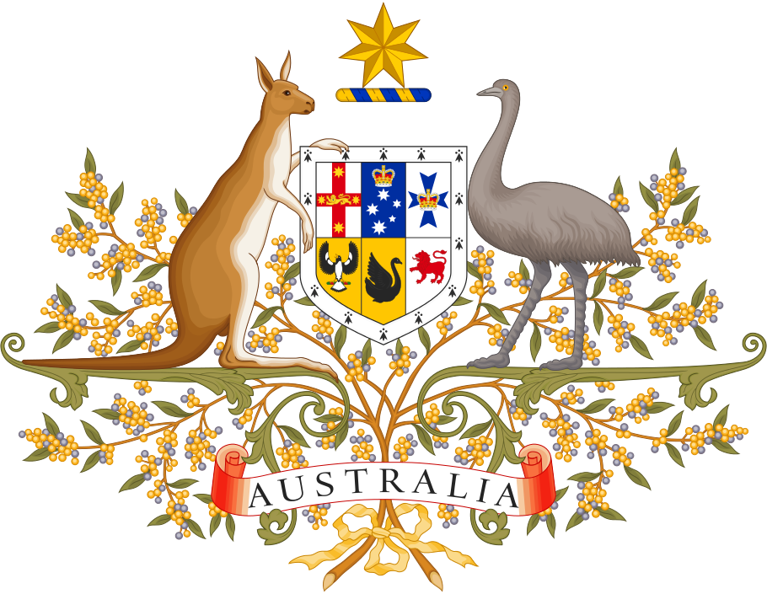

Australians all let us rejoice,
For we are young and free;
We’ve golden soil and wealth for toil;
Our home is girt by sea;
Our land abounds in nature’s gifts
Of beauty rich and rare;
In history’s page, let every stage
Advance Australia Fair.
In joyful strains then let us sing,
Advance Australia Fair.

Beneath our radiant Southern Cross
We’ll toil with hearts and hands;
To make this Commonwealth of ours
Renowned of all the lands;
For those who’ve come across the seas
We’ve boundless plains to share;
With courage let us all combine
To Advance Australia Fair.
In joyful strains then let us sing, Advance Australia Fair.

Music can be listened to here:
https://www.youtube.com/watch?v=MCQLmteikdM
or
tinyurl.com/GOA

