Name: ………………………………………….. Class: ……………….

Australia: End of Unit Assessment

Write the correct answer or circle the correct answer.

1. Tick the statements that are true. (2)

* Australia is a continent
* Australia is part of the United States of America
* Australia is a country

2. Australia has lots of beaches you can visit. (1)

TRUE FALSE

3. Why are there so many beaches? (1)

……………………………………………………………………………………………………………….

4. Name one of the oceans that meets Australia’s shores. (1)

…………….……………………………………………………………………………………………….

5. Name two of the different landscapes you might find in Australia. (2)

……………………………………………………………………………………………………………….

6. Australia has a lot of sunshine and nice weather but sometimes the weather can cause a disaster. What kind of disaster might the weather create? (1)

……………………………………………………………………………………………………………….

7. Circle the Australian flag. (1) 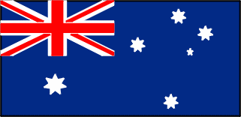 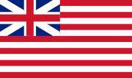 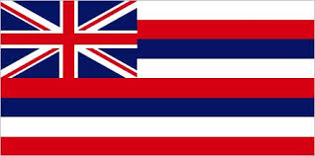

8. The summer season in Australia happens during the same months as it does in the UK. TRUE or FALSE? (1)

TRUE FALSE

9. After Australia was settled by people from Europe, what language was mostly spoken? (1)

a) French b) English c) German d) Spanish

10. Whilst mining and farming is important in Australia why do fewer people work in these areas than they used to? (1)

……………………………………………………………………………………………………………

11. What is the population of Australia? (1)

a) 22 thousand b) 220 thousand c) 220 million d) 23 million

12. Would you rather live in rural or urban Austrlia? Why? (3)

…………………………………………………………………………………………………………………………………………………………………………………………………………………………………………………………………………………………………………………………………………………………………………………………………………………………………………………………………………
…………………………………………………………………………………………………………………
…………………………………………………………………………………………………………………

