More Information…
About the Grand Tour and Tourists

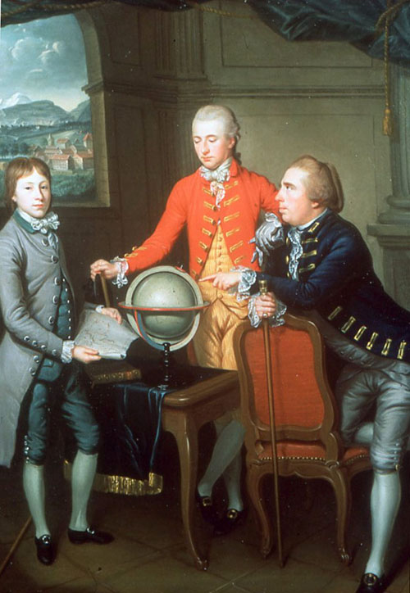
What was a ‘Grand Tour’ and who took part?
The Grand Tour was the name given to a particular form of overseas travel that began in the mid seventeenth century and remained fashionable for about two hundred years. It involved the undertaking of a long trip overseas, almost always around Europe, by the young upper classes of European society. While a few women did take part in their own Grand Tour, it was more often seen as a rite of passage for young men from wealthy families, marking their movement from school boy to learned nobility. One should remember that at that time travel outside one’s own country was seen as unusual and extremely adventurous – a privilege enjoyed only by the richest in society.
Source: Jean Preudhomme (1774) National Museum of Scotland (Flickr Creative Commons)
Duke Douglas Hamilton on his Grand Tour in Geneva

Where did the early ‘tourists’ go?
With travel to countries outside Europe purely in the hands of the sponsored explorers of the time, the early tourists followed popular and well developed routes that encompassed sites of cultural, artistic and historical significance across Europe. France, Germany and Holland featured in almost all tours while Italy was a very fashionable destination with Venice, Rome, Naples and Florence all seen as essential stops on the tour. Later tourists would also add Alpine regions to their itinerary as modes of transport on the tour became more advanced.
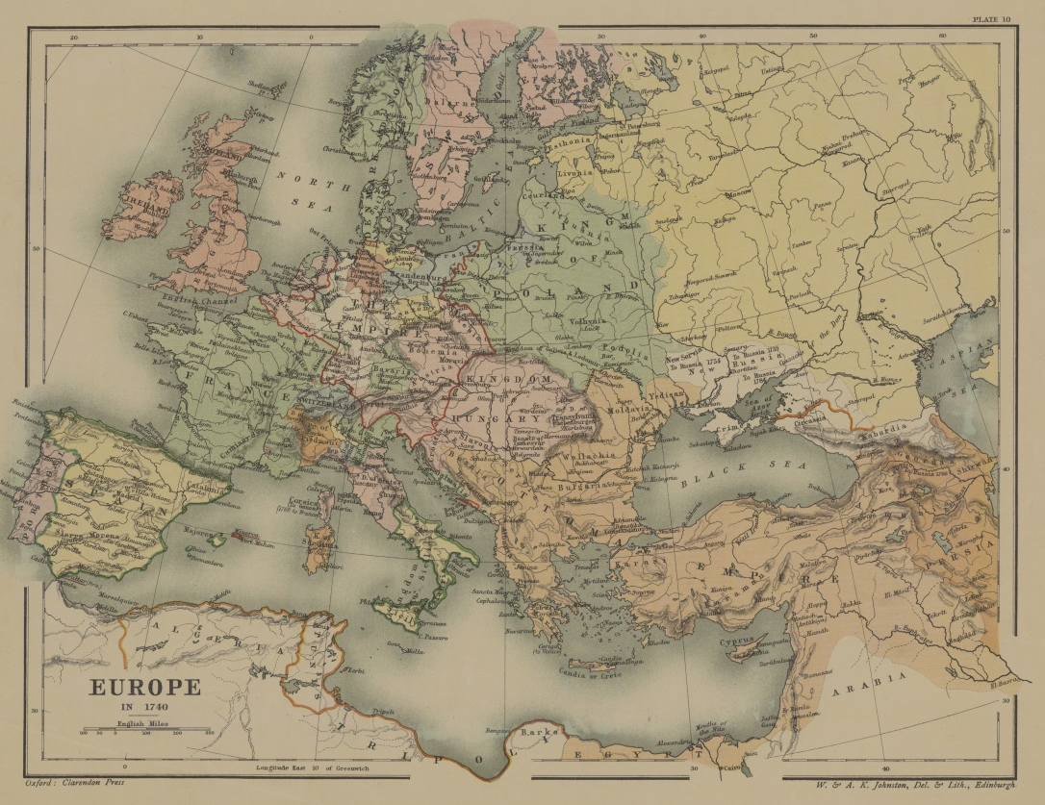

Source: Flickr Creative Commons user UConn Libraries

Europe at the times of the early ‘Grand Tours’

What did they hope to achieve?
There was a strong educational element to all tours. There was a common belief at the time that a young man could not be truly educated unless he had studied the history of civilisation, including painting, sculpture, music, architecture and language. By exposure to Renaissance and Baroque art forms, as well as by mixing with other well-connected young men, the tourists hoped to secure their own future in academic and social circles on their return.

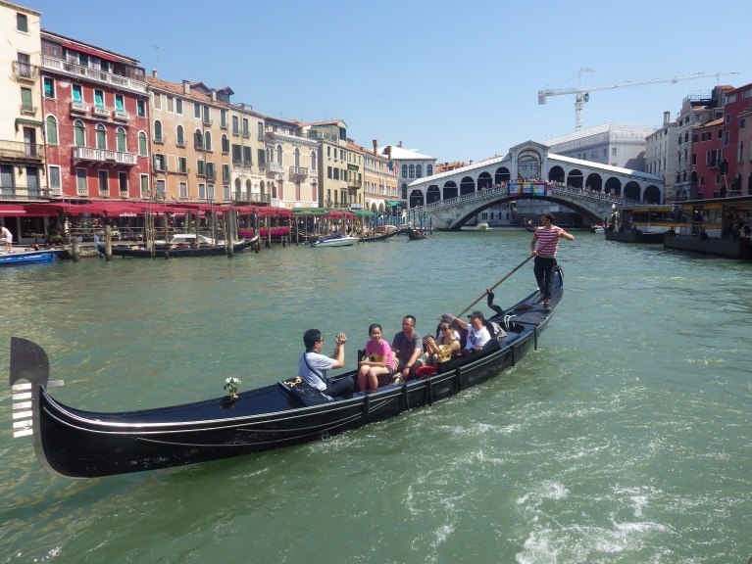
How did the ‘tourists’ travel?
With a lot of time and money at their disposal the tourists could take their time journeying between stops. They moved via horse drawn coach, a form of transport that could be packed down and sold easily as and when the tourist decided to take up residence in certain cities. One or more tutors would be hired to act as guides for the young man alongside servants and a driver. To travel light was quite rare and most tourists also paid for the carriage of huge pieces of luggage. They would return, often after several years away, with multiple crates, packed with antiquities, pieces of art and furnishings that were extremely fashionable at the time.
Source: Flickr Creative Commons user Elaine-Louise
Venice was a popular destination for tourists studying art and architecture

Why did it end?
Ironically, the invention of large scale and cross border rail lines signalled the demise of the Grand Tour. These improvements opened foreign travel up to the middle classes and the removal of its elitist character made the Tour less appealing to its wealthier clientele. With it becoming easier and cheaper to travel to Europe, the need for an extended stay was also removed and shorter, more spontaneous visits to cities around the continent began to become more popular.
One could also argue that the idea of a ‘Grand Tour’ that marks a young person’s coming of age has not gone away at all. Independent travel in ‘gap years’ has become a time to mature, explore, and learn about new cultures for many young people and represents an increasingly important niche in tourism marketing.

