Pakistan floods

Introduction
The monsoon season is part of the natural rhythm of life in Southern Asia and typically happens from June to September each year. Due to the topography (shape, height and physical features) of the land, floods and landslides are common when the rain comes and saturates the ground.

The rains account for ⅓ of the region’s annual rainfall and provides essential fresh water. However, this monsoon season has been particularly strong, with initial estimates of rainfall being 50-60% higher than a typical season, which has had a huge impact in both Pakistan and India.

Location and date
Heavy rain had been affecting the region since the monsoon started in late June with subsequent flash flooding taking place in both Pakistan and India. However, the two flood events being explored here started on Friday August 15, 2025, in the Khyber Pakhtunkhwa province in northern Pakistan.

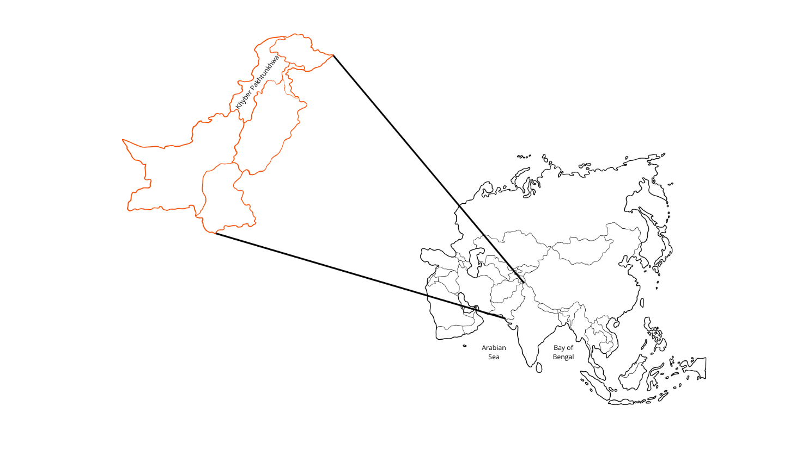
Figure 1: Location of the Khyber Pakhtunkhwa province in Pakistan. Credit: RGS

Causes
Moisture-ladened air was pushed inland from the Bay of Bengal and the Arabian Sea by strong south-westerly monsoon winds. This, coupled with increasing areas of low pressure in the area, created the perfect conditions for successive downpours of rain.

On the morning of Friday August 15, 2025, a particular weather phenomenon called a cloudburst – intense localised rainfall usually exceeding 100mm in an hour – took place in the Buner District where 150mm rain fell within 1 hour.

This mountainous region of Pakistan contains steep valley sides, created from thousands of years of erosion and weathering, funnelled the rainfall down the valley in a surge of water.

Along with the extensive rainfall, this region of Pakistan has over 13,000 glaciers, 10,000 of which are melting at an alarming rate. Meltwater released from these glaciers is becoming more frequent and less predictable adding to the amount of water flowing down the valleys in the form of glacial bursts. Retreat of these glaciers leaves debris from frost shattering and plucking on the slopes which is easily carried by flood water. Therefore, when water surges down the valleys, it brings with it vast amounts of rocks and debris.

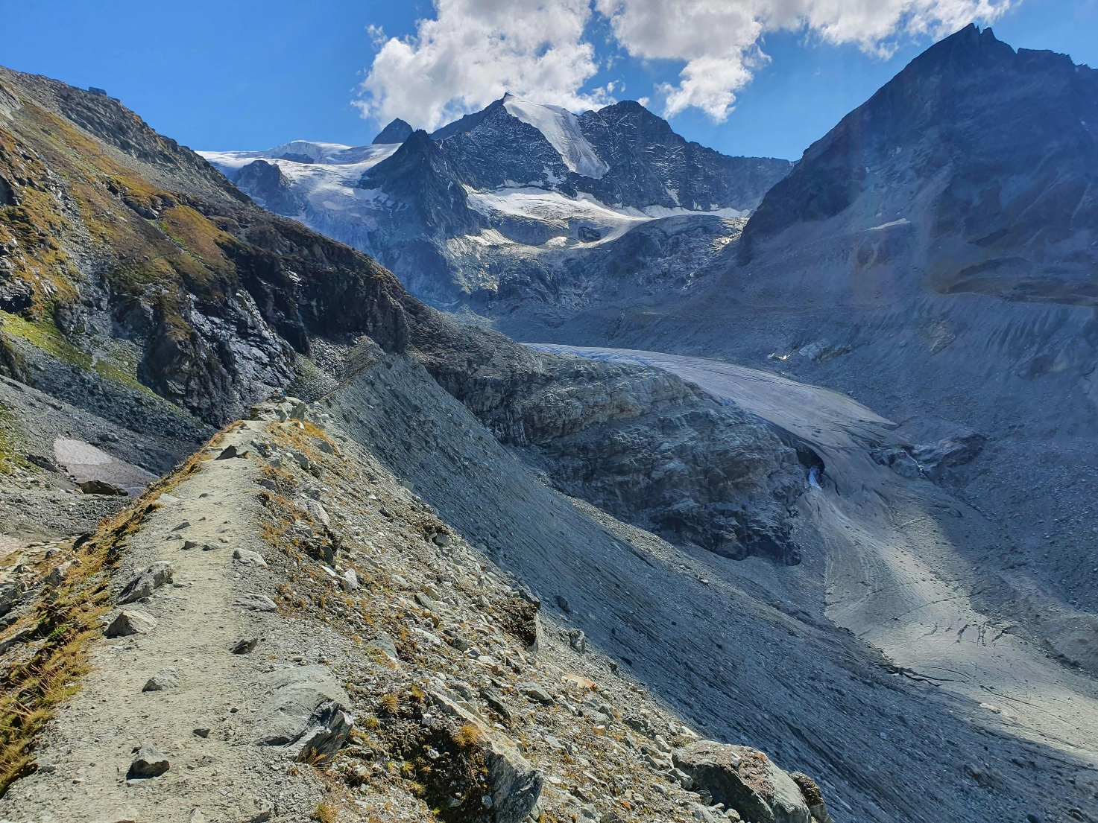
Figure 2: A glaciated valley showing rock and debris. Image credit: Svetlana Bützberger, Pexels.

Effects
The flood water was so strong that it made swift work of anything in its path, including toppling buildings and bridges. The BBC reported that 50% of all houses in the region were completely destroyed. The load carried within the flood water also buried many things including people, roads and possessions.

In addition, the already saturated soils and the angle of the valley slopes created landslides which contributed to the damage.

In that single cloudburst event, more than 300 people were killed in the province of Khyber Pakhtunkhwa with 217 deaths in the Buner District alone. In the Swat valley, a quick-thinking teacher saved the lives of over 900 people when they realised that the river was going to flood and swiftly evacuated the area before the river swept through, destroying parts of the school building.

Across the region, crops and livestock have been damaged or washed away leaving many farmers without enough to support their families and disrupting their livelihoods.

After the flood water receded, a thick layer of fine mud called silt was left behind covering anything in its path and limiting the availability of fresh water. According to Islamic Relief, 40% of households reported cases of diarrhoea from contaminated water with fears over more illnesses from water borne diseases in the coming months.

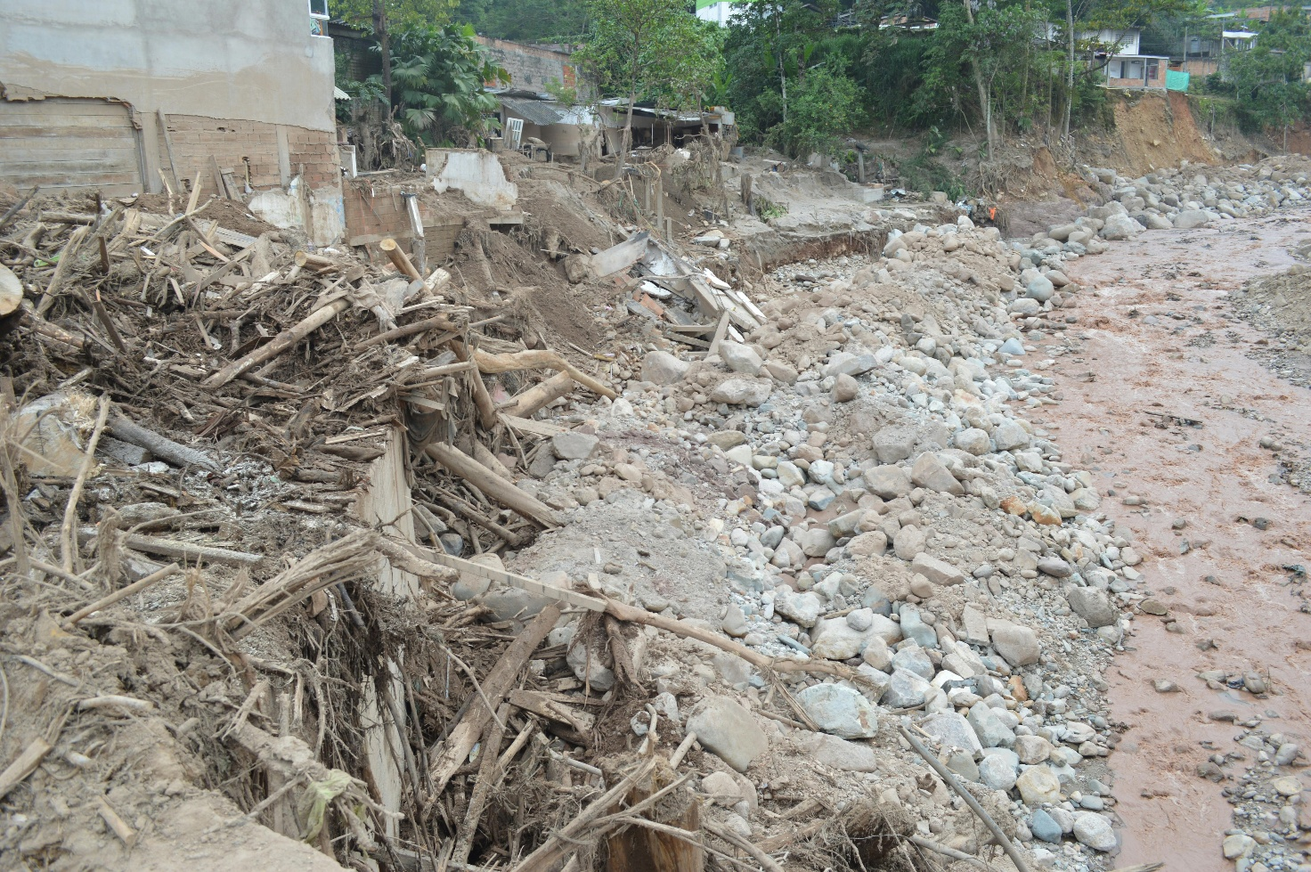
Figure 3: Examples of debris left after flooding. Image credit: Franklin Peña Gutierrez, Pexels.

Responses
120 people from Rescue 1122 - the emergency service covering most of Pakistan - were deployed to the region to assist with evacuations and rescue efforts.

The British Red Cross along with the Red Cresent have worked with the National Disaster Management Authority to help coordinate rescue efforts. They have also set up relief shelters and providing financial and material support to those affected by the flooding. For example, they have provided water filtration units and mosquito nets to those families who have had to leave their homes.

However, the more remote areas of the region have received limited aid due to these areas being difficult to access. Therefore, local communities are working together to help in the clean up of shops, homes and businesses.

With global warming increasing the rate of glacial retreat along with the intensity of monsoons becoming more frequent due to climate change, there are calls for more long-term planning to be put in place to prevent more hazards in the future.

Further reading
Himalayan flash floods: climate change worsens them, but poor planning makes them deadly. The Conversation, August 27, 2025.
'The water had no mercy': Hundreds killed as floods ravage north Pakistan. BBC, August 18, 2025.
Pakistan Monsoon Flood 2025 DREF Operation MDRPK028. Reliefweb, August 28, 2025.
Flash floods kill at least 159 people in Pakistan after huge cloudburst. The Guardian, August 15, 2025.

Flash floods ravage Pakistan: Cloud burst and melting glaciers create perfect storm of destruction. Global Voices, September 2, 2025.
Flash floods ravage Pakistan: Cloud burst and melting glaciers create perfect storm of destruction. Global Voices, September 2, 2025.
'The water had no mercy': Hundreds killed as floods ravage north Pakistan. BBC, August 18, 2025.

