Lesson two: Australia’s Diverse Landscape
This activity can be used as a teacher demonstration for younger pupils and an independent activity for older pupils.

Overlay Map Activity Instructions
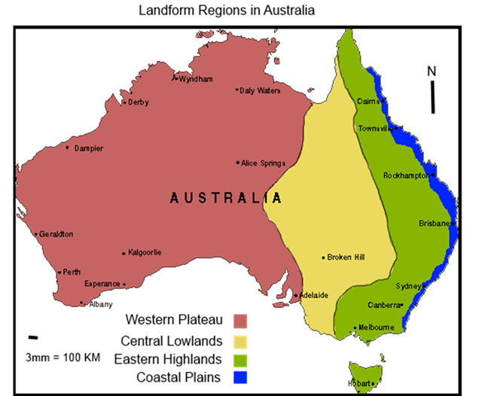

ROUND ONE
- Start with your handout Base map of Australia: draw the landform regions on to the base template using the image above as a guide.

- Create a map key to show the colour code of each landform region.
Starter questions:
- Which landform region covers the largest area of Australia?

- Which landform region is located in the east?

- Which landform region is located in the west?

ROUND TWO
- Trace map two (Highland areas) on to transparency film or tracing paper and give the map a title.

- Label the highland areas in another colour and create a key.

- Answer the questions below:

- Which landform region is Uluru or Ayers Rock in?

- Which landform region are the Flinders and Barrier Ranges in?

- Which landform regions is the Great Dividing Range in?

ROUND THREE
- Trace map three (Bodies of Water/Rivers and Waterways) on to transparent film or tracing paper.

- Answer the questions below:
- Which landform region is Lake Eyre in?

- Over which three landform regions does the Murray-Darling River Basin flow (Darling, Lachlan, Murrumbidgee and Murray Rivers)?

CHALLENGE ROUND
- Trace map one (areas of high rainfall) on to transparent film or tracing paper.

- Answer the questions below:

- Which landform region has the highest rainfall and which has the lowest?

