China – or not?

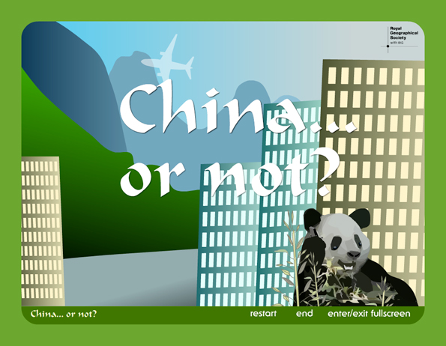

Here are a set of 20 statements about China – indicate whether you think the statement is true [ T ], false [ F ] or you are unsure [ U ].

Answers are at the end!

1. China is the largest country in the world (by area).
[ ]

2. China has the largest population in the world.
[ ]

3. Half of all the world’s cement is used in China each year.
[ ]

4. In China, the people who speak Mandarin Chinese cannot be understood by those that speak Cantonese Chinese.
[ ]

5. It is considered bad luck in China if fish or chicken is served without its head and tail.
[ ]

6. About 60% of the Chinese people live in large towns and cities.
[ ]

7. In order to prepare the dish called Peking Duck, the duck has first to be inflated with a pump!
[ ]

8. In China, there are many different political parties to vote for.
[ ]

9. Aircraft, helicopters, machine guns and grenades made in China are sold to many different countries around the world.
[ ]

10. China is in the southern hemisphere.
[ ]

11. The capital of China is called Shanghai.
[ ]

12. Since the year 2000, China has built and launched 22 satellites into space using its own designed and built rockets.
[ ]

13. The last emperor of China was only two years old when he became emperor.
[ ]

14. Between 1979 and 1986, couples in China were only allowed by law to have a single child.
[ ]

15. The Chinese invented toilet paper and fireworks.
[ ]

16. 2007 is known as the year of the dragon and 2008 as the year of the snake.
[ ]

17. Only about 15% of the land in China can be used for growing food.
[ ]

18. The Chinese flag is red with 10 small stars in the top left-hand corner.
[ ]

19. Hong Kong was ruled by the British until 1997 when it was given back to China.
[ ]

20. The Emperor of China used to live in the Forbidden City.
[ ]

China – or not? - Answers

1. China is the largest country in the world (by area).
[ F ]
It is the fourth largest in the world.

2. China has the largest population in the world.
[ T ]

3. Half of all the world’s cement is used in China each year.
[ T ]

4. In China, the people who speak Mandarin Chinese cannot be understood by those that speak Cantonese Chinese.
[ T ]

5. It is considered bad luck in China if fish or chicken is served without its head and tail.
[ T ]

6. About 60% of the Chinese people live in large towns and cities.
[ F ]
Only about 30% of the population live in towns and cities.
7. In order to prepare the dish called Peking Duck, the duck has first to be inflated with a pump!
[ T ]

8. In China, there are many different political parties to vote for.
[ F ]
There is only one political party (The Communist Party)

9. Aircraft, helicopters, machine guns and grenades made in China are sold to many different countries around the world.
[ T ]

10. China is in the southern hemisphere.
[ F ]
China is in the northern hemisphere

11. The capital of China is called Shanghai.
[ F ]
The capital of China is called Beijing (it used to be called Peking)

12. Since the year 2000, China has built and launched 22 satellites into space using its own designed and built rockets.
[ T ]

13. The last emperor of China was only two years old when he became emperor.
[ T ]

14. Between 1979 and 1986, couples in China were only allowed by law to have a single child.
[ T ]

15. The Chinese invented toilet paper and fireworks.
[ T ]

16. 2007 is known as the year of the dragon and 2008 as the year of the snake.
[ F ]
2007 was the year of the pig and 2008, the year of the rat
17. Only about 15% of the land in China can be used for growing food.
[ F ]

18. The Chinese flag is red with 10 small stars in the top left-hand corner.
[ F ]
The Chinese flag has only one large star and four small stars
19. Hong Kong was ruled by the British until 1997 when it was given back to China.
[ F ]

20. The Emperor of China used to live in the Forbidden City.
[ F ]

