|  |
| --- |
| Indonesia |

**Location Basic facts**

|  |  |
| --- | --- |
| Population per km2 | 144 (2022) |
| GDP/GNI per person | $4,580 (2022) |
| Climate | Tropical with a wet and dry season |
| HDI (closest to 1 = most developed) | 0.740 (2023) |

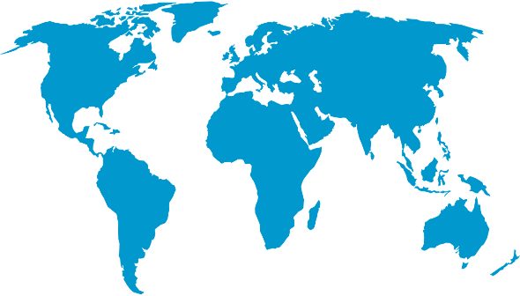

*World Map © Clker-Free-Vector-Images, Pixabay*

**Environmental facts**

|  |  |
| --- | --- |
| 1. | Indonesia is largely volcanic and as such the natural disasters are earthquakes, volcanic eruptions and tsunamis. It is estimated that since 2004, at least one major natural disaster has occurred in Indonesia every month. In addition, cities such as Jakarta are sinking (Jakarta by an average of 1-15cm per year). |
| 2. | Indonesia consists of over 17,000 islands with a coastline of 54,720 kilometres. 60% of its population lives along its coastline. It is mainly low-lying areas made up of mudflats, sand and silt with a spine of volcanic mountains along the southerly side of the Islands. |
| 3. | 64% of the coastline is covered in multiple habitats, 27% mangrove forests (19.5% of the total world mangrove area) and 5% warm water corals. Indonesia is part of the ‘coral triangle’ and is home to over 3,000 fish species, 6 or the 7 marine turtle species and important areas for marine mammals including dugongs (sea cows), whales and dolphins. |

**Protecting the oceans**

Eastern Lombok Island as well as Western Sumbawa Island suffered significant damage to the reefs. In 2004, the local government took steps to protect the marine environment by introducing two marine parks. In addition, Indonesia’s Sustainable Oceans Program (ISOP) aims to reduce the impact on their ocean by supporting sustainable fishing techniques and coastal livelihoods, build healthy coastal and marine ecosystems, reduce marine pollution and stregthenpolicy in protecting marine environments.

*Indonesian flag © Clker-Free-Vector-ImagesPixabay*