Shipping carousel sheet

Station 1: Green Ports, Duqm

Read the information in the article and create a mind map below summarising how Duqm is becoming a green port.
Green ports

Station 2: Wind powered ships
Read the information about the wind powered ships and use that information to annotate the image below. Make sure you focus on how these help reduce emissions.
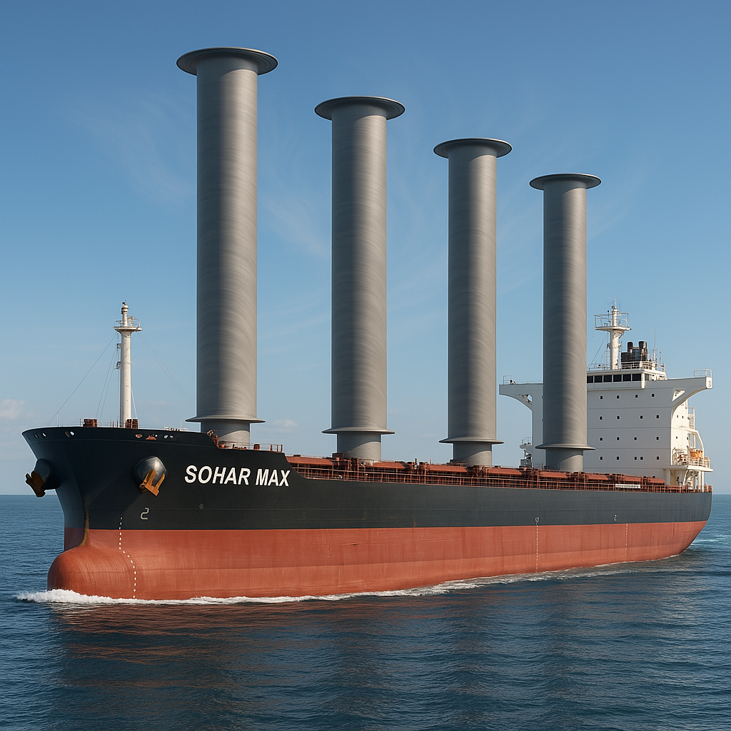
Image: Computer generated image of bulk carrier Sohar Max fitted with rotor sails. Credit: RGS

Station 3: Fuel saving shipping
Complete the table below using the information on the different methods to use in shipping which reduce fuel consumption. Include a brief description on how it works, a sentence on positives and one on negatives of each method. Challenge: which one do you think works most effectively and why?

Method | How it works | Positives/Pros/Benefits | Negatives/Cons/Costs
Weather routing
Constant velocity
Route optimisation software

Station 4: Alternative fuel
Watch the video then fill in the gaps in the text below to look at alternative fuel for shipping to reduce carbon emissions.

There is a textbox at the bottom of the page with the missing words/numbers. NOTE: some are repeated.

New studies released have identified the potential for two alternative fuels from the traditional diesel in shipping: __________ and ____________.

_____________ are work in a similar way to traditional fuels but come from the production of ________ rather than the extraction of oil. However, as the demand for ________ increases, more land is needed for this which may have an impact on food production. Therefore, looking at alternatives such as ________ or burning __________ might be a more sustainable solution.

Ammonia is a naturally ____________ free fuel. Current production of ammonia however, accounts for around ______% of global carbon dioxide emissions. If produced sustainably, it could greatly cut ______________ emissions in shipping.
waste Ammonia greenhouse algae carbon 1.8 Biofuels crops

Station 5: Shipping policies
Read the information about different policies that aim to help minimise the impact of shipping on marine life. Draw an annotated diagram or a series of diagrams to summarise this information.

Ammonia: Zero-carbon fertiliser, fuel and energy store. The Royal Society

