A breath of fresh air? - getting around Bangkok

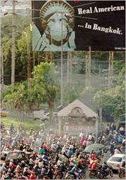
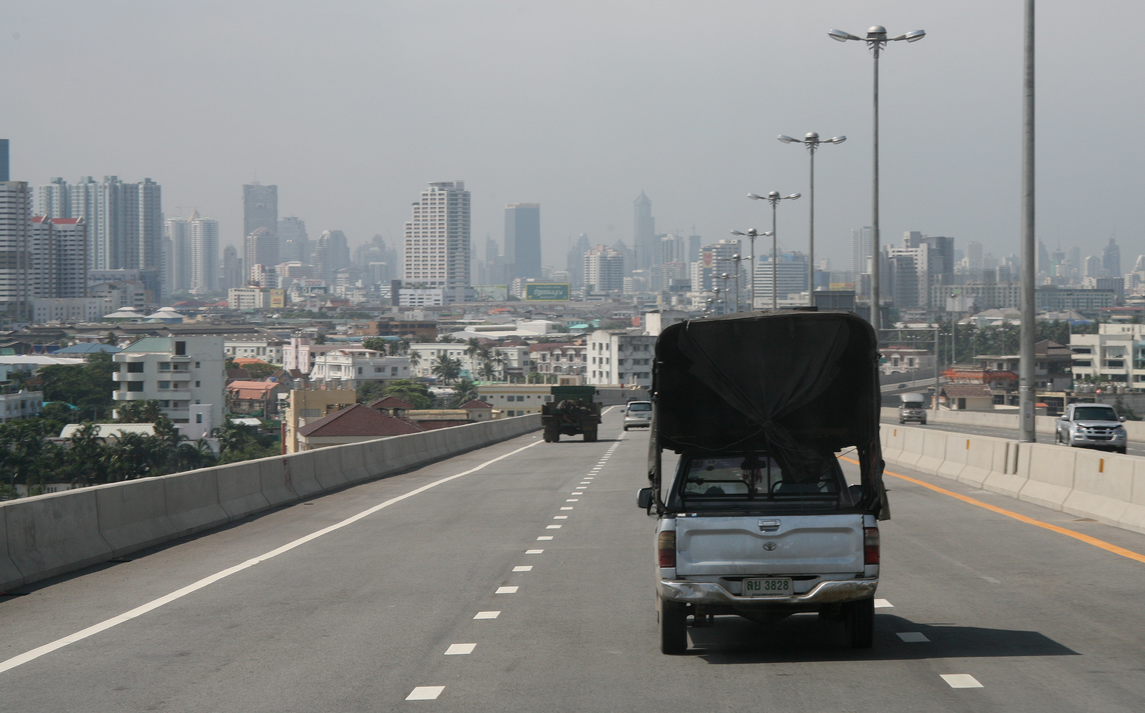
Filthy fumes billowing from exhaust pipes, particularly from two-stroke motorbikes, into the humid, tropical air was part of life in Bangkok.

After a long battle against air pollution, Bangkok’s skies are blue again, and much cleaner than those of other big Asian cities like Beijing, Shanghai and New Delhi.

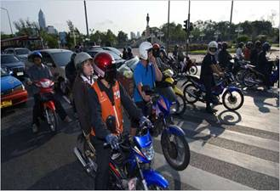
In a drive for cleaner air, the Thai government encouraged companies to produce cleaner cars that run on fuel known as gasohol, a mixture of petrol and biofuel made from sugar cane and other plants. The government also introduced higher taxes to lower the number of motorcycles on the street.
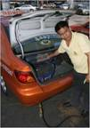
At the same time, Bangkok’s taxis had to adjust their engines to run on cleaner liquefied petroleum gas. Stricter controls on exhaust emissions were added on other vehicles, much like those imposed on drivers in European cities. To stop the amount of dust particles adding more dirt to the air, street cleaning and washing became more regular.
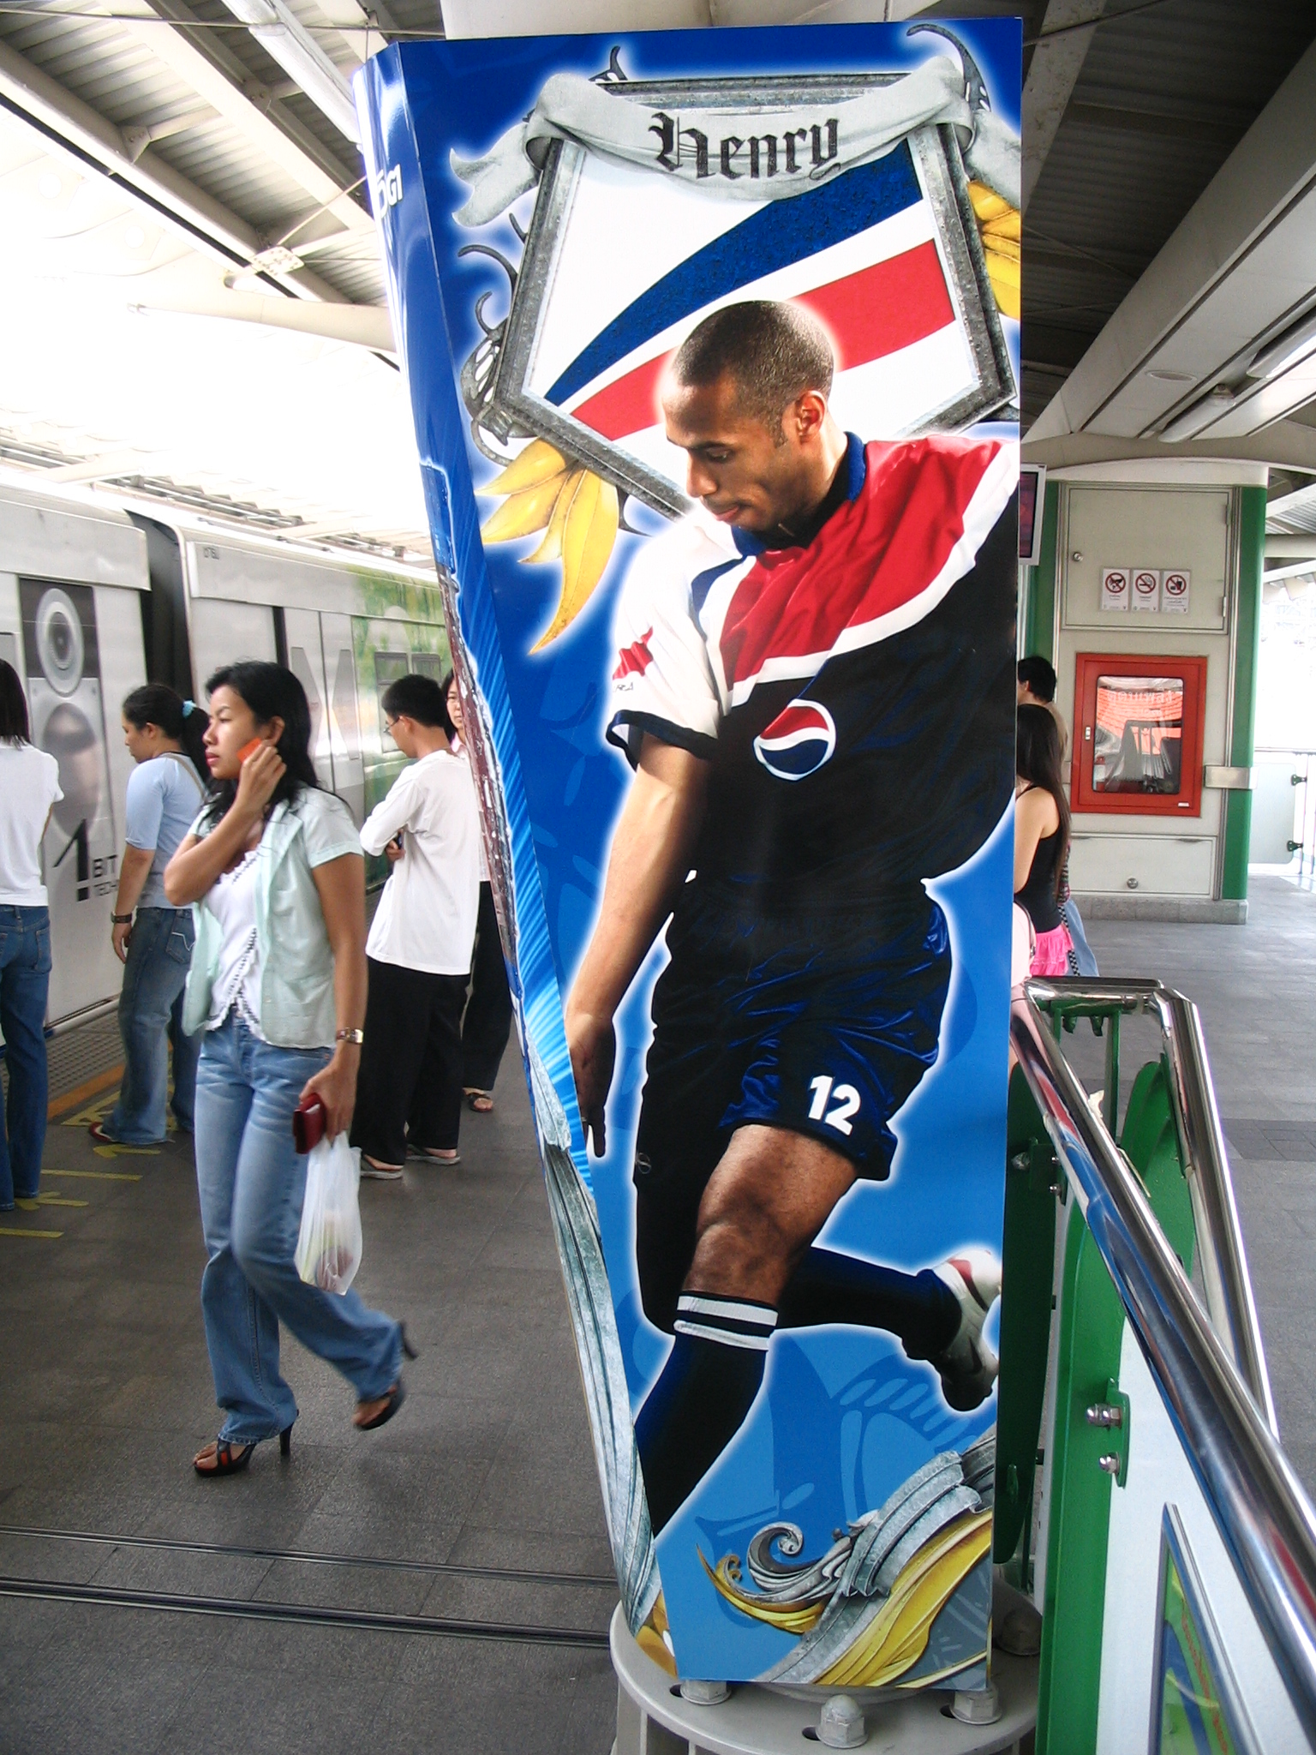
Bangkok’s skytrain, a network of electrified trains, has really helped too. Since it opened in 1999 the skytrain has offered a alternative cheap, clean and quick way to travel along two routes through the city. In 2004, the subway (or underground train network) was added to the transport mix, making it more attractive to leave the car behind.

The astonishing result is that while the number of vehicles on Bangkok’s streets has continued to rise by another 40 percent over the last ten years, levels of the most dangerous types of pollution - small dust particles that trap themselves in the lungs - have nearly halved.

The fight against pollution and traffic congestion is far from won in Bangkok. Many still complain about poor air quality and long traffic jams during rush hour. But it could have been so much worse ...

based on article:
March 6, 2007
Bangkok Journal
Breathing Easier as the Battle for Blue Skies Pays Off By THOMAS FULLER

