|  |
| --- |
| Norway |

**Location Basic facts**

|  |  |
| --- | --- |
| Population per km2 | 9 (2022) |
| GDP/GNI per person | $94,540 (2022) |
| Climate | Maritime (warm summers and cold winters) |
| HDI (closest to 1 = most developed) | 0.964 (2021) |



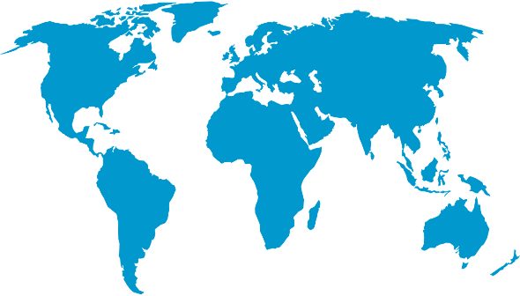

*World Map © Clker-Free-Vector-Images, Pixabay*

**Environmental facts**

|  |  |
| --- | --- |
| 1. | Norway is susceptible to flooding, high winds, droughts, heavy snowfall, landslides from areas with clay soils and avalanches. With increased temperatures from climate change, Norway could experience more forest fires. |
| 2. | Norway’s coastline is the second longest in the world (after Canada) covering a staggering 102,937 kilometres. This includes its 1,190 fjords and 50,000 islands. The coastline is mainly made from igneous and metamorphic rocks which are typically resistant to erosion. In addition, the coastline is dramatic with high cliffs and small low bays. No wonder the best way to see this coastline is by sea. |
| 3. | Norway’s coastline provides the perfect location for kelp and seagrass meadows along with salt marshes. These provide shelter and food for over 150 species of marine fish and 3,500 marine invertebrates. These then feed into the larger food web supporting larger mammals such as seals, beluga and sperm whales. |

**Protecting the oceans**

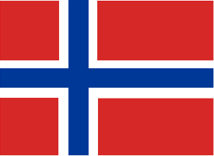Since 2002 Norway has developed integrated management plans to support the sustainable conservation of the marine environment. This management plan draws on the cooperation of the government, local people and NGOs to develop research, maintain the function of the ecosystem as well as unlock potential for sustainable jobs in ocean industries.

*Norwegian flag © Clker-Free-Vector-Images, Pixabay*