|  |
| --- |
| The Land of Frankincense: student sheet |

# Starter – a commodity

Discuss

Discuss the picture below then answer the questions.

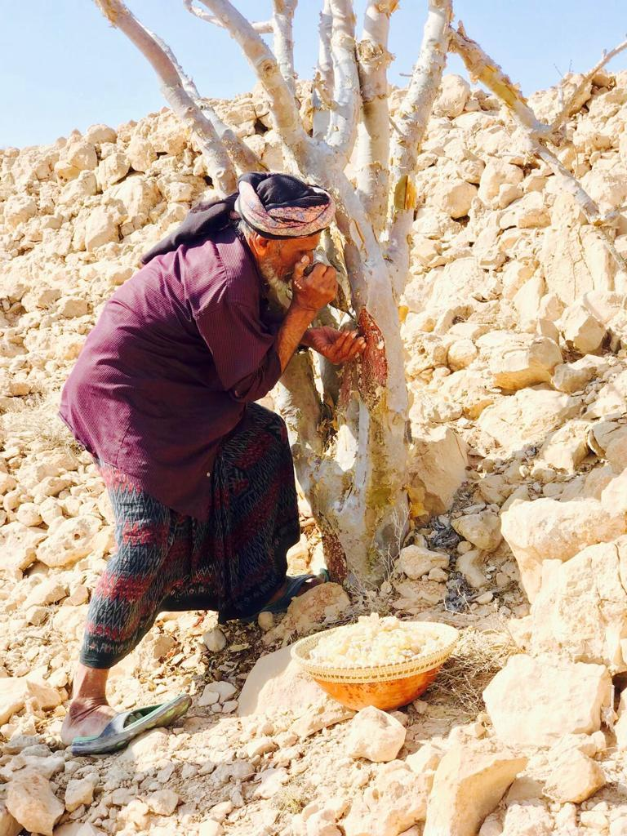

Image Source: © [ayublab](https://ayublab.com/frankincense)

What does it show? What are it uses around the world?

___________________________________________________________

______________________________________________________________________________________________________________________

What geographical features can you identify in the picture, and how might they influence the cultivation of frankincense in Oman?

___________________________________________________________

___________________________________________________________

How does the landscape in the picture reflect the climate of the region where frankincense is produced?

___________________________________________________________

___________________________________________________________

___________________________________________________________

Describe the traditional harvesting methods of frankincense depicted in this picture.

___________________________________________________________

___________________________________________________________

What challenges might farmers face in this region when cultivating and harvesting frankincense?

___________________________________________________________

___________________________________________________________

___________________________________________________________

___________________________________________________________

**Card sort**

On the next page, there are 15 cards on frankincense. Follow the steps below to complete the activity.

Firstly, sort them into two piles, one for ‘I did not know that’ and the other for ‘I knew it’.

Next, sort the cards into two groups, under the headings: description, and uses.

Challenge: are there any card which you cannot sort into these sections? What additional category would you add?

Frankincense is an iconic commodity harvested from wild Boswellia trees

Frankincense trees are found in the Dhofar region of Oman, particularly in the Wadi Dawkah area

Frankincense is used in essential oils for its calming properties

Traditional Chinese medicine believes it has health benefits

Skincare products use frankincense for anti-inflammation and anti-aging

The Land of Frankincense is a UNESCO World Heritage

It is a unique scent used in perfumes

In many religious and spiritual practices incense is burnt

Overharvesting and habitat loss have led to a decline in frankincense tree populations

It has healing properties of cleansing and enlightenment

Burning Frankincense is a key aspect of hospitality, and drives off flying insects

The desert these trees grow in is called Rub’ al Khali

It has been used for over 5,000 years, famously given to Jesus by the Magi (the Three Wise Men)

It is known as the desert tears

Frankincense is commonly used in meditation practises

# The frankincense tree

Using the relevant slides in the PowerPoint, annotate the image of the frankincense tree with the information about the physical characteristics and plant adaptations.

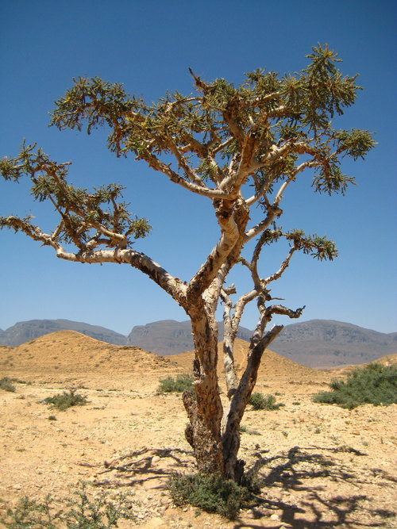

Source: Boswellia Sacra Tree @ [ayublab](https://ayublab.com/frankincense)

**The Khareef**

Asia’s hottest and driest mountains are found on the Arabian Peninsula, in Oman. Each year an incredible transformation takes place as fog sweeps inland transforming the rocky slopes into lush green meadows.

Watch episode 2 of Asia on BBC iPlayer, titled Above the Clouds.

What lies in the far south of Oman? 19:10

___________________________________________________________

___________________________________________________________

___________________________________________________________

___________________________________________________________

How hot can temperatures reach? 19:20

___________________________________________________________

___________________________________________________________

___________________________________________________________

___________________________________________________________

In the summer, what happens as moist tropical air meets the surface of the sea? 20:00

___________________________________________________________

___________________________________________________________

___________________________________________________________

___________________________________________________________

What is the Khareef? 20:30

___________________________________________________________

___________________________________________________________

___________________________________________________________

___________________________________________________________

What is Arabia’s best adapted desert animals? 22:15

___________________________________________________________

___________________________________________________________

___________________________________________________________

___________________________________________________________

What dwindles as summer ends? 22:55

___________________________________________________________

___________________________________________________________

___________________________________________________________

___________________________________________________________

**ArcGIS**

For online map work, ArcGIS is a great platform to use to produce GIS work. The Geography Visualiser is a tool to which allows users to explore the world with maps and data.

Follow the steps on the PowerPoint to create an online ArcGIS map on temperature and precipitation in Oman.

The layers you will add to your ArcGIS map are:

Global Temperature 1981-2010

Global Rainfall 1981-2010

You will need to click on Map layers then the Legend icon to understand the colour coding.

Using your ArcGIS map (with the above layers added), describe the environment where the Frankincense trees grow.

___________________________________________________________

___________________________________________________________

___________________________________________________________

___________________________________________________________

# The impacts

Open the [WWF Risk Filter Suite](https://riskfilter.org/water/explore/map) and select the Water Availability from the drop-down options.

Describe the physical abundance or lack of freshwater resources for the region.

___________________________________________________________

___________________________________________________________

___________________________________________________________

___________________________________________________________

___________________________________________________________

Zoom in on the Sea of Oman, where the majority of the population live. What level of water risk is present along this populated coastline?

___________________________________________________________

___________________________________________________________

Read the following [article](https://www.aljazeera.com/news/2024/4/16/heavy-rains-kill-18-in-oman-as-flash-floods-lash-uae) and use it to identify other impacts of climate change in Oman.

___________________________________________________________

___________________________________________________________

___________________________________________________________

# Extension: the land of frankincense vs. wild frankincense in Ethiopia

Read the article How the west’s wellness industry is driving Ethiopia’s frankincense trees towards extinction. Answer the 4 questions below.

How has the increased demand for frankincense in the wellness industry impacted natural habitats across Ethiopia and Arabia?

___________________________________________________________

___________________________________________________________

What are some of the ethical concerns surrounding the trade of frankincense resin, especially in relation to the local communities?

___________________________________________________________

___________________________________________________________

How do the prices of frankincense products in western markets compare to the earnings of those who collect the resin?

___________________________________________________________

___________________________________________________________

What steps can be taken to ensure the sustainable harvesting of frankincense and protect it from extinction?

___________________________________________________________

___________________________________________________________