|  |
| --- |
| India |

**Location Basic facts**

|  |  |
| --- | --- |
| Population per km2 | 481 (2024) |
| GDP/GNI per person | $10,030 (2023) |
| Climate | Tropical |
| HDI (closest to 1 = most developed) | 0.644 (2022) |

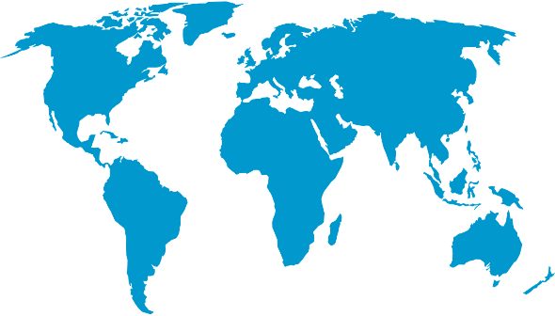

*World Map © Clker-Free-Vector-Images, Pixabay*

**Environmental facts**

|  |  |
| --- | --- |
| 1. | Although flooding is the most common natural disaster in India, the country can also suffer from many others including earthquakes, cyclones, drought, landslides and most recently extreme heat where temperatures close to 50°C were recorded daily throughout May and June of 2024. |
| 2. | India's mainland has a coastline that spans around 7,517 kilometres and is bordered by the Bay of Bengal, Indian Ocean, and Arabian Sea. The coastline features a diverse range of landscapes, including shallow beaches, sand dunes, bays, lagoons, and cliffs. |
| 3. | 26% of India’s coastline is covered in mangrove forests, with 8% being saltmarshes. The diversity of sea temperatures and supporting ecosystems means that India hosts a wide variety of marine species including sea cows (dugongs), humpback whales, sharks and turtles. |

**Protecting the oceans**

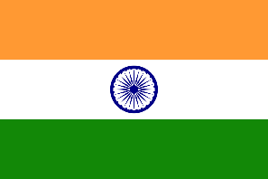The Maritime Zones of India Act in 1976 ensures that the Indian government can preserve and protect the marine environment around India. In 2021 India committed to conserve and protect 30% of the world’s oceans through local and international cooperation. India had lost up to 40% of its mangrove forests and has adopted a new conservation effort to restore them through replanting (6000 mangrove saplings in the Krishna district alone) and protected coastlines.

*Indian flag © zodiacmoh, Pixabay*