Copper in the twenty-first century activity sheet

Mineral security
Copper is an important metal which has become increasing crucial to top exporters and consumers in the developed world. The reasoning behind the surge in demand is that electrical equipment has exponentially increased as production costs have gone down, and consumer spending has gone up. The global COVID-19 pandemic has increased pressure on copper supplies as many countries in the western world have seen an increase in home entertainment, gaming, and the growing electrification of transport, all of which requires copper wiring.

Copper is a non-ferrous metal and is an example of a mineral. Reserves, export/imports, global commerce, and the environmental impacts of copper extraction are all key elements of studying mineral security in A Level geography.

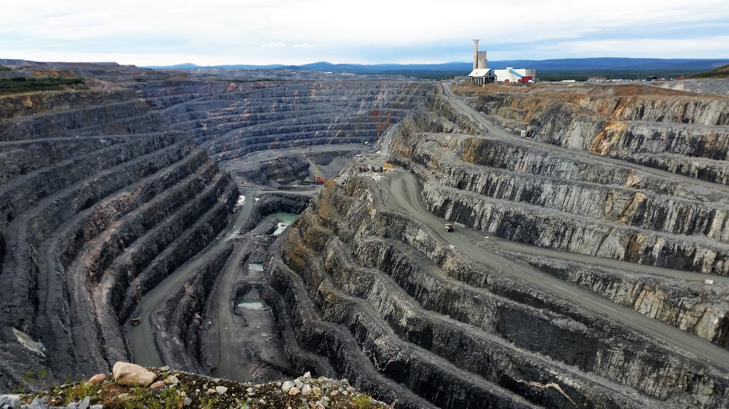
Figure 1 Boliden Aitik, Sweden’s largest open pit copper mine © Neta623 Pixabay

The specification
AQA A Level 3.2.5.5 Mineral security with reference to iron ore or a specified globally traded non-ferrous metal ore e.g., copper, tin, manganese.

Edexcel 7.6.a Superpower resource demands (food, fossil fuels, and minerals) can cause environmental degradation and carbon emissions contribute disproportionately to global warming.

OCR 2.b. The use of ocean energy and mineral resources is a contested issue.

WJEC Development in Sub-Saharan Africa 4.3.9 The influence of resource base of minerals and energy sources on development.

Introduction
Copper is shiny and reddish in colour. It was first used over 10,000 years ago during the Bronze Age. It was during this time that humans started to work with metal, specifically by adding tin to copper to make a harder and more durable metal for weapons and tools. It is now the third most used metal in the world.

The element copper is a low reactivity metal, found as nuggets in the ground, called native copper. The 3 main ores are: chalcopyrite, bornite, and malachite. 50% of copper production comes from chalcopyrite making it the most common source.

In the Earth’s crust metals are split into abundant metals: aluminium, iron, magnesium, manganese, and titanium, and scarce metals: copper, lead, zinc, gold, and silver. Copper is classified as a scarce element (see Table 1 in Appendix A) because it is only present in the Earth’s crust at a concentration of about 67 parts per million.

Over time, the importance of copper to human civilisation has lessened. However, in the twenty-first century copper is once again being touted as a precious metal because demand levels have surged whilst supply issues persist. It has the following end uses:

- Electrical wiring (it is ductile, and can be drawn into thin wires)
- Domestic plumbing (it is biostatic, preventing bacteria growth (producing safe drinking water)
- Boiler and heat exchanges (long-term degradation does not occur; it is corrosion resistant)
- Making brass (copper is mixed with zinc, producing an alloy — strong and tough)
- Making coins (although a modern-day copper coin is now 97.5% zinc)
- Electrification of transport (it is an excellent conductor of electricity — and heat)

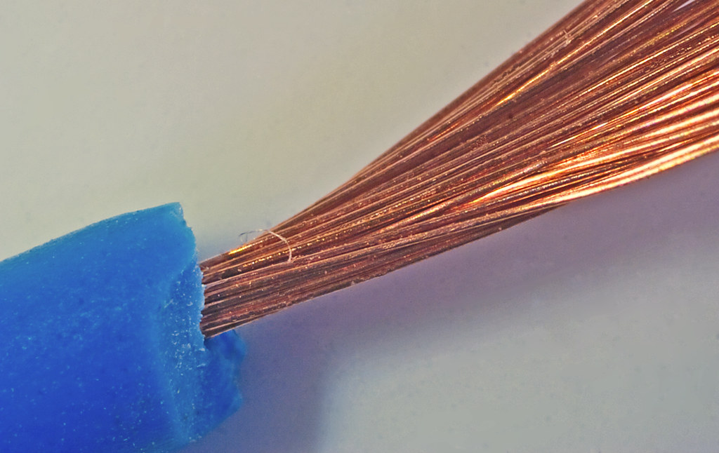
Figure 2 stripped electrical wire © Tudor Barker

Copper use in electric cars is linked to efficiency due to energy savings — this can help extend the life of the car. A conventional internal combustion engine (ICE) car has between 8 and 22 kilograms of copper in it, compared to a hybrid electric vehicle (HEV) which has approx. 39 kilograms, a plug-in hybrid electric vehicle (PHEV) with 60 kilograms, and a fully electric (EV) containing 83 kilograms of copper.
Copper is one of the most efficient thermal-electrical conductors we have and is therefore essential for the renewable energy sector.

Copper deposits
Copper deposits are classified on the basis of how they form. There are multiple major deposit classes but the main two are: porphyry copper deposits (PCD), and sediment-hosted copper deposits (SCD). All copper ores are the result of hot and high-pressure geothermal solutions bringing the copper up to cool near the surface.

PCD are found in volcanic areas when hot, metal-bearing fluids percolate up through the Earth’s crust. Copper is then released into ‘veins’ in the rock, creating disseminated copper deposits. This occurs by a process called mineral precipitation — when ions in solution come together to form solid minerals i.e., copper. PCD is a major deposit class because it is currently the world’s main source of copper (50-60% of world production).

Copper is also found in SCD, such as sandstone and shale, when the metal-bearing fluids become chemically trapped in the rock strata. SCD is the world’s second most important source of copper accounting for approx. 20% of world production.

There are other rarer deposit examples throughout the UK: volcanic stratabound (NW Scotland), volcanic massive sulphide (Isle of Anglesey), mafic-intrusion (NE Scotland), vein-style (SW England, Lake District, and central Wales), the Breccia pipes (N Wales), Skarn-type (Dartmoor), and Epigenetic deposits in limestones (English Midlands).

The 2007 British Geological Survey (BGS) commodity profile for copper states that the amount of copper accessible for land surface mining is 1.6 billion tonnes, with a further 0.7 billion tonnes available in deep-sea nodules.

South America has the largest measured amount of copper in the world. In 2019 Chile was the world’s leading copper producing country, making 5.787 million tonnes of copper. Table 3 in Appendix C shows the top 5 copper producing countries of 2015 versus 2019.

Future trends for copper
In the past it was thought that copper supply disruption was a low risk.

The COVID-19 pandemic has rapidly increased copper demand, particularly in the electronics industry. Throughout 2020 there has been a sustained uptick in consumer electronics. For example, after stay-at-home orders were issued in March 2020, smart phones, televisions, e-games, and games consoles became even more desirable. As a result, copper demand (and price) also grew in 2020. It is expected to continue to grow by up to 600% (relative to 2021) by 2030, compared to current levels, with warnings that global supply might become increasingly strained across the world.

A recent article in the Economist laid out the future possibilities for mining copper, explaining that pretty much all the non-ferrous natural resources that are currently excavated come from ancient volcanoes. Scientists now suggest that copper may be drilled from deep copper-sulphide ores which have formed as sulphur-rich gases have risen up through active volcanoes and encountered metal-rich brines trapped in the rocks above the magma, in the same way as oil is exploited.

In the UK another future possibility is the rediscovery of disused copper mines that might once again become financially viable as the price of copper rises. In 2020, a surprise discovery of copper was uncovered in the Cornish parish of Gwennap, near Redruth. The mineral company Strongbow Exploration hopes the United Downs mine will be at the forefront of a renaissance for Cornish mining.

Peak copper is difficult to estimate because the copper is almost completely recyclable. Approximately 35-40% of world demand is currently met by recycling the metal, while in Europe as much as 50% of copper-use is from recycled sources. In spite of this peak copper remains a useful indicator of the global economy’s health due to the diversified nature of the metal’s end uses.

Go to the ArcGIS dashboard Worldwide copper production in 2019 to visualise where copper was mined in that year (ArcGIS Online for Schools is free to access).

In Cornwall, the plan for United Downs mine is to continue additional drilling to find out just how big the zone is. For Gwennap, which was once the richest copper producing region in Cornwall, a resurgence just might be in sight.

Activity
- Using the data in Appendix A Table 1, draw a pie chart to represent 2019 copper production for the top 10 producers.

- Go to the USGS Global copper map, describe the global distribution of both PCD and SCD.

- Now go to the USGS prospective map for global copper deposits. Which regions of the world have future potential for:

  - Porphyry copper (PCD)
  - Sediment-hosted copper (SCD)

- Study the data in Appendix C Table 3. Which country increased their production the most between 2015 and 2019?

- Which country’s production decreased?

- Go to page 41 on Copper in the British Geological Society’s report on Stream sediment geochemical atlas of the United Kingdom (click the download button). Describe the pattern of copper deposits in the UK.

- Go to the ArcGIS dashboard Worldwide copper production in 2019 using your ArcGIS school log-in (free for schools). Which country was the number 1 producer of mined copper that year?

- Analyse the spatial pattern of copper production across the world in 2019.

- Is there another way to visual this dataset? Take the information for the top 20 producers and create your own infographic on copper in 2019.

Further reading
- People may one day drill for copper as they now drill for oil (email sign up to read for free) www.economist.com/science-and-technology/2021/07/07/people-may-one-day-drill-for-copper-as-they-now-drill-for-oil

- Travelling through deep time to find copper for a clean energy future www.theconversation.com/travelling-through-deep-time-to-find-copper-for-a-clean-energy-future-163822

- Cornish copper find www.theguardian.com/business/2020/apr/22/cornish-copper-find-metal-mining-industry

- Copper: material for a modern world www.youtube.com/watch?v=wQ2Hp028VCE

- Copper Alliance: copper content per vehicle type www.copper.org/publications/pub_list/pdf/A6191-ElectricVehicles-Factsheet.pdf

- Five reasons Strongbow Exploration’s latest discovery could be transformational www.proactiveinvestors.co.uk/companies/news/918284/five-reasons-strongbow-explorations-latest-discovery-could-be-transformational-918284.html

- USGS 2021 Mineral Commodity Summaries Annual Publications report data www.pubs.usgs.gov/periodicals/mcs2021/mcs2021-copper.pdf

- 2007 BGS commodity profile for copper

Appendix A

Element | Abundance % | Category
Oxygen | 46.6 | Nonmetal
Silicon | 27.7 | Metalloid
Aluminium | 8.1 | Metal
Iron | 5.0 | Metal
Calcium | 3.6 | Metal
Sodium | 2.8 | Metal
Magnesium | 2.1 | Metal
Potassium | 2.6 | Metal
Titanium | 0.44 | Metal
Manganese | 0.095 | Metal
Barium | 0.043 | Metal
Strontium | 0.038 | Metal
Zirconium | 0.017 | Metal
Vanadium | 0.014 | Metal
Chromium | 0.010 | Metal
Nickel | 0.0075 | Metal
Copper | 0.0055 | Metal
Zinc | 0.0070 | Metal
Cobalt | 0.0025 | Metal
Lead | 0.0013 | Metal
Uranium | 0.00027 | Metal
Tin | 0.0002 | Metal
Tungsten | 0.00015 | Metal
Mercury | 8x10-6 | Metal
Silver | 7x10-6 | Metal
Gold | <5x10-6 | Metal
Platinum Metals | <5x10-6 | Metal
Table 1 © ResearchGate paper on abundance of metals in the Earth’s crust

Appendix B

Production of copper
Country | 2019
Albania | 3000
Argentina | 0
Armenia | 91198
Australia | 934055
Azerbaijan | 2210
Bolivia | 4478
Botswana | 0
Brazil | 363300
Bulgaria | 70927
Burma | 219000
Canada | 560781
Chile | 5787400
China | 1683700
Colombia | 7641
Congo, Democratic Republic | 1420386
Cyprus | 703
Dominican Republic | 6047
Ecuador | 6100
Eritrea | 16008
Finland | 32592
Georgia | 900
India | 30466
Indonesia | 351000
Iran | 310000
Kazakhstan | 608000
Korea, Dem. P.R. of | 2000
Kyrgyzstan | 7000
Laos | 140935
Mauritania | 29620
Mexico | 768542
Mongolia | 297500
Morocco | 34000
Namibia | 16108
North Macedonia | 7100
Oman | 0
Pakistan | 13049
Panama | 147480
Papua New Guinea | 99398
Peru | 2455440
Philippines | 71892
Poland | 449000
Portugal | 41553
Romania | 9200
Russia | 813600
Saudi Arabia | 67300
Serbia | 44000
Slovakia | 17
South Africa | 52501
Spain | 170556
Sweden | 99332
Tajikistan | 8500
Tanzania | 10000
Turkey | 73500
USA | 1260000
Uzbekistan | 141000
Vietnam | 30551
Zambia | 797518
Zimbabwe | 8700
Table 2 production of mine copper (in tonnes) source: BGS Minerals UK

Appendix C

Country | 2015 production mil. tonnes | 2019 production mil. tonnes
Chile | 5.750 | 5.787
China | 1.750 | 1.683
DRC | 0.990 | 1.420
Peru | 1.600 | 2.455
USA | 1.250 | 1.260
Table 3 copper production 2015 versus 2019

Answers

- Global copper distribution is concentrated in specific regions of the world, namely, on the western seaboard of South and North America, throughout much of Asia (bar the Indian subcontinent), across the Indonesian islands and in Australia up the east coast. Tracts are also found in the central African copper belt of the DR of Congo and Zambia and some scattered sediment-hosted deposits in northern Europe (with PCD copper to the south).

Figure 3 production of mined copper (in tonnes) for 2019

You can view this data as a percentage by visiting the Statista webpage Distribution of mine production of copper worldwide in 2019, by country.

- Undiscovered copper resources are identified by the empty red symbol on the map. These future potential sites are largely located close to existing mine sites, with new locations found in Alaska, Central America, the Dominican Republic, Newfoundland, Nova Scotia (Canada), Sardinia (Italy), Kazakhstan, Indonesia, and Australia.

- PCD deposits of copper (a hard igneous rock) are largely found along tectonic plate boundaries: up the west coast or South and North America, throughout Turkey and Iran on the Arabian plate, and throughout East Asia and Indonesia. SCD deposits are more concentrated with clusters across Germany and Poland in Europe, in Kazakhstan, in New Brunswick and Nova Scotia along the Canadian coast, and in Siberia Russia.

- From 2015 to 2019 Peru increased its production of copper exponentially from 1,600,000 to 2,455,440 tonnes. This is a 53.4% increase over the 4 years.

- China decreased their copper production by 67,000 from 1.750 to 1.683 million tonnes.

- Low concentrations of copper occur over the Grampian Mountains in Scotland. Higher copper concentrations occur in southern Scotland and south-west England. The coals and black shales of the Midland Valley of Scotland, north-east Scotland, north-east England, central England, and south Wales are linked to higher levels of copper (due to mining activity). Deposits are found in natural high concentrations in Northern Ireland, across the Scottish islands of Mull and Skye, the Midland Valley of Scotland, and the Lake District, all areas of predominantly igneous rocks.

- Chile mined and produced 5,800,000 tonnes of copper in 2019.

- The spatial distribution of copper production in 2019 was spread across the 3 largest continents of Asia, Africa, and the Americas (South America in particular). Within these continents 3 individual countries dominated the market with China, the Democratic Republic of Congo, and Chile all being in the top 4 producers worldwide. Indeed, only about 65% of copper is found in just 5 countries on Earth: Australia, Chile, Mexico, Peru, and the US. The lowest of the 58 countries are Argentina, Botswana, and Oman where production fell to 0 in 2019. An anomaly is the immense copper reserves found in Chile, now described as a ‘copper powerhouse’. In 2020 Chile copper mine production accounted for 28.5% of global copper production that year. The Dominican Republic is also unusual as it is the only Caribbean country with copper deposits in the region.

- As instructed.

