|  |
| --- |
| Bahamas |

**Location Basic facts**

|  |  |
| --- | --- |
| Population per km2 | 41 (2021) |
| GDP/GNI per person | $31,520 (2022) |
| Climate | Sub-tropical |
| HDI (closest to 1 = most developed) | 0.827 (2018) |

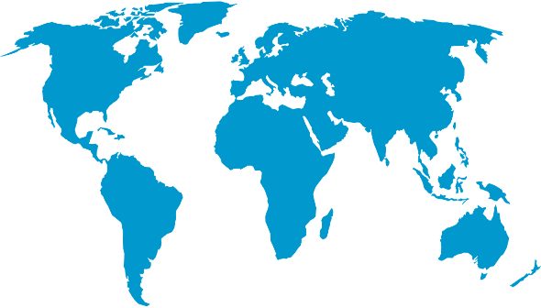

*World Map © Clker-Free-Vector-Images, Pixabay*

**Environmental facts**

|  |  |
| --- | --- |
| 1. | The Bahamas are located within the Atlantic hurricane belt which means they are susceptible to strong winds, heavy rainfall and flooding from rain as well as storm surges from the sea especially between the months of September - November. The islands are also susceptible to increasing sea level rise. |
| 2. | The Bahamas is a series of islands in the Caribbean with 3,542 kilometres of coastline. The islands are manly low lying, only a few metres above sea level, with gently sloping beaches. The highest point on any of the islands is 64 metres above sea level. The main bedrock is limestone which acts like a sponge with water rising in from the sea and contaminating fresh water. |
| 3. | Due to the warm, shallow seas, the Bahamas host a variety of marine life such as corals, mangroves, saltmarshes and seagrasses. This provides shelter and food for many species of fish, crustaceans and mammals of which there is thought to be at least 25 different species. |

**Protecting the oceans**

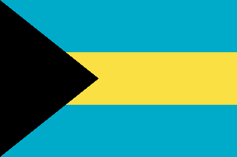Bahamians rely heavily on the ocean ecosystem as a source of income and food. They have declared 10% of its waters as marine protected areas. They are advocates for sustainable fishing practices in their waters along with working with different organisations to help conserve critical species and protect coral, seagrasses and mangroves which will in turn help to reduce the impacts of flooding and storms on the islands.

*Bahamian flag © OpenClipart-Vectors, Pixabay*